Title
Authors Name(s)¹,
¹Affiliation(s)
Corresponding author: aieds2@example.com

Abstract
Enter your abstract here. Ensure the content fits within one A4 page.

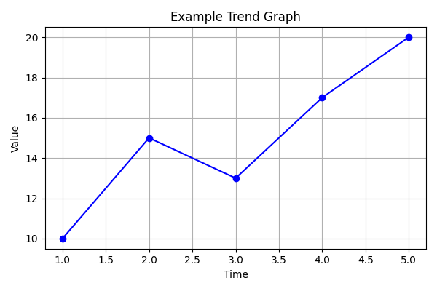
Figure 1: Example

References
[1] Author(s), Journal name, Vol., Page (Year).
[2] Author(s), Journal name, Vol., Page (Year).
…

